CNNs: Image Representation & Spatial Learning
Learning goal: Understand how image pixels are represented as numbers, how convolution filters create feature maps, why padding/stride/pooling change spatial size, how dropout and batch normalization help training, and how LeNet, VGG, and ResNet differ.

1. How a computer represents an image
A digital image is a grid of pixels. A grayscale pixel usually stores one intensity value (often 0–255). An RGB image stores three values per pixel: Red, Green, and Blue.
Example: a 64 × 64 RGB image is represented as a tensor with shape 64 × 64 × 3. The three channels contain colour intensities. During model training, values are commonly converted to floating point and normalized, for example from 0–255 to 0–1.
Why spatial structure matters: nearby pixels form edges and textures; those local patterns combine into parts, and parts combine into objects.
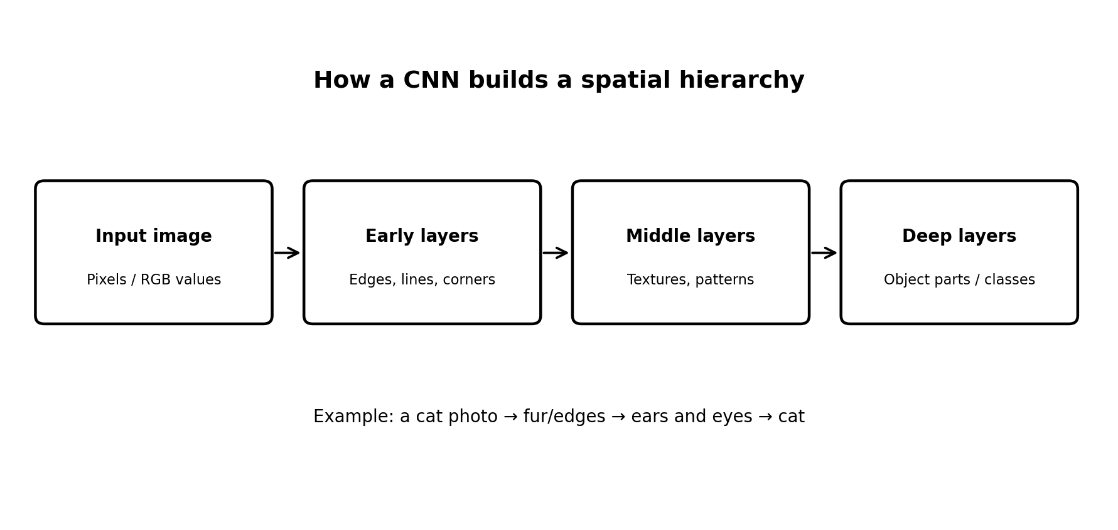
Real-world example: In a medical X-ray, early CNN layers may respond to edges and contrast; deeper layers may combine those patterns into shapes that help a model flag a possible abnormality. The model supports clinical review; it does not replace a qualified clinician.

2. Convolution, filters, and feature maps
A filter (also called a kernel) is a small matrix of learnable weights. Convolution slides the filter across the image. At each location, values are multiplied element-by-element and summed, producing one value in the output feature map. During training, the network learns filter weights that are useful for its task.
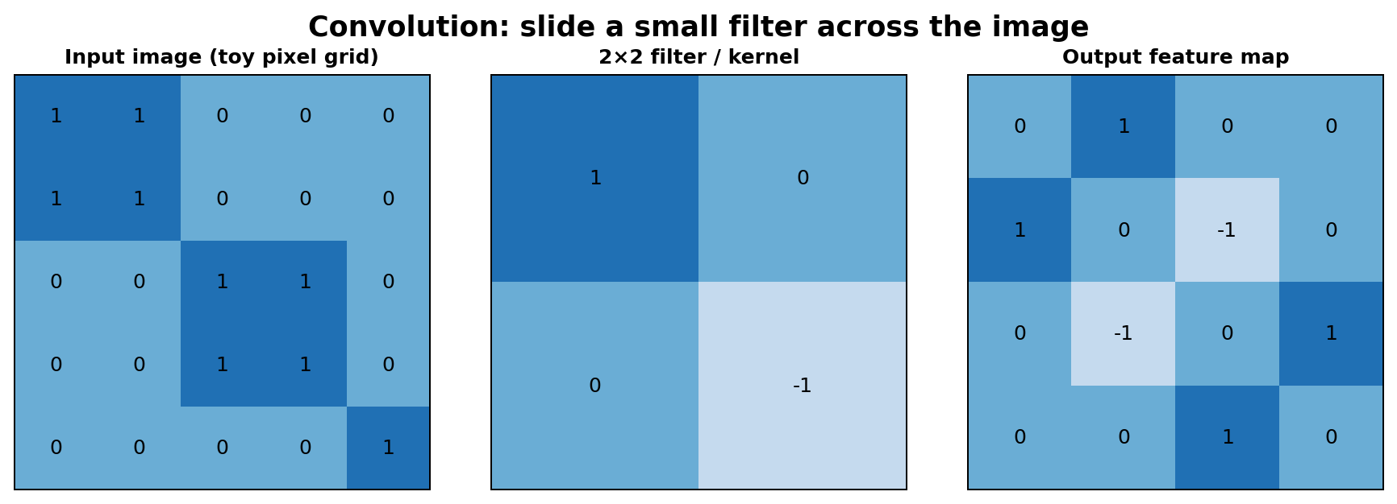
Toy calculation: the top-left 2×2 image patch is [[1, 1], [1, 1]]. With the displayed filter [[1, 0], [0, −1]], the output is (1×1) + (1×0) + (1×0) + (1×−1) = 0. Real CNN filters typically contain learned decimal weights, not just −1, 0, and 1.

Key terms
- Filter/kernel: small weight matrix that responds to a local pattern.
- Feature map: the grid of responses produced by applying a filter.
- Channels: input colour channels or learned feature channels. Multiple filters usually create multiple output feature maps.
- Receptive field: the part of the original image that can influence a particular activation.
Real-world example: For road-sign recognition, early filters may respond to borders and colour transitions; later layers can combine these into circles, triangles, digits, or symbols.

3. Padding and stride
Padding adds extra pixels (often zeros) around the border. It helps control output dimensions and lets filters process border regions. 'Valid' convolution usually means no padding; 'same' padding is chosen to preserve spatial dimensions for stride 1.
Stride is how many pixels the filter moves each time. Stride 1 scans every adjacent position; stride 2 skips positions and reduces the output resolution.
For a 1D dimension, output size is floor((N + 2P − K) / S) + 1, where N = input size, P = padding, K = kernel size, and S = stride. Apply the formula separately to height and width.
Input | Kernel / stride | Padding | Output size
32×32 | 3×3 / 1 | 1 | 32×32
32×32 | 3×3 / 1 | 0 | 30×30
32×32 | 3×3 / 2 | 1 | 16×16
Rule of thumb: padding controls border treatment/output size; stride controls the step size and often reduces spatial resolution.

4. Pooling
Pooling summarizes a small region of a feature map. Max pooling selects the largest value; average pooling computes the mean. A common example is 2×2 max pooling with stride 2, which halves height and width.
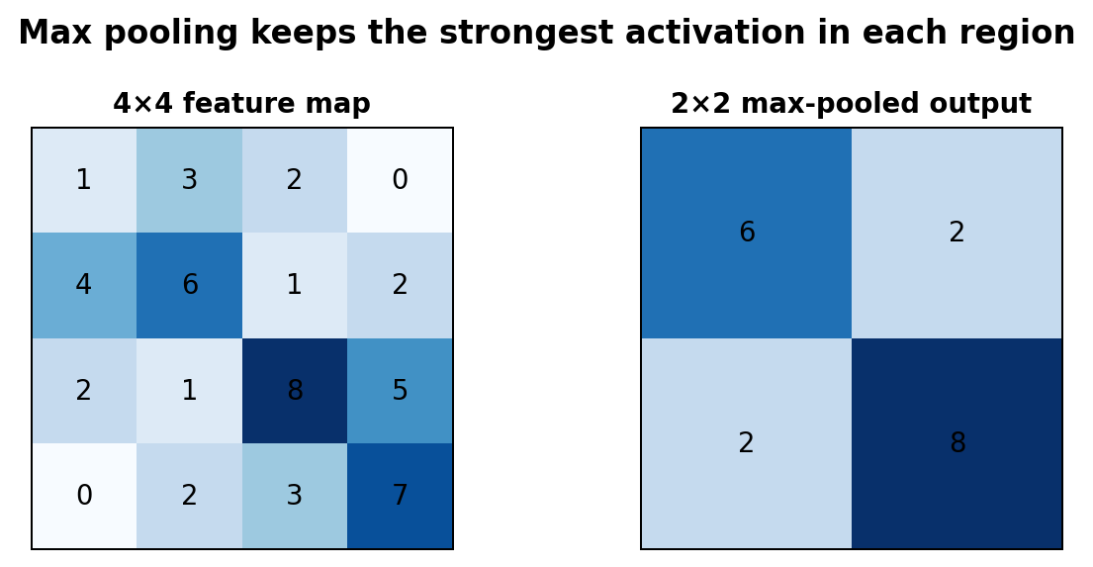
In the example, each 2×2 region contributes its maximum, turning a 4×4 map into a 2×2 map. This reduces computation and can make representations less sensitive to small shifts, but it also discards some location detail.
Real-world example: In an industrial inspection camera, pooling can preserve a strong activation for a scratch or defect while reducing the amount of feature-map data passed to later layers. Tiny defects can still be lost, so pooling choices need validation.

5. Dropout and Batch Normalization

Dropout
During training, dropout randomly sets a fraction of activations to zero. This discourages the network from relying too heavily on a few neurons and can reduce overfitting. Dropout is disabled at inference time; standard frameworks scale activations appropriately during training.
Example: With dropout rate 0.3, roughly 30% of the selected activations are temporarily dropped on each training pass. It does not mean 30% of the whole image is permanently deleted.

Batch Normalization (BatchNorm)
BatchNorm normalizes activations using mini-batch statistics during training, then applies learnable scale and shift parameters. At inference, it normally uses running statistics collected during training. It can make optimization more stable and often allows effective learning rates, though results depend on the model and batch size.
Simple contrast: Dropout injects randomness to regularize learning; BatchNorm standardizes intermediate activations to support optimization. They solve different problems and are not interchangeable.

6. CNN architecture introductions
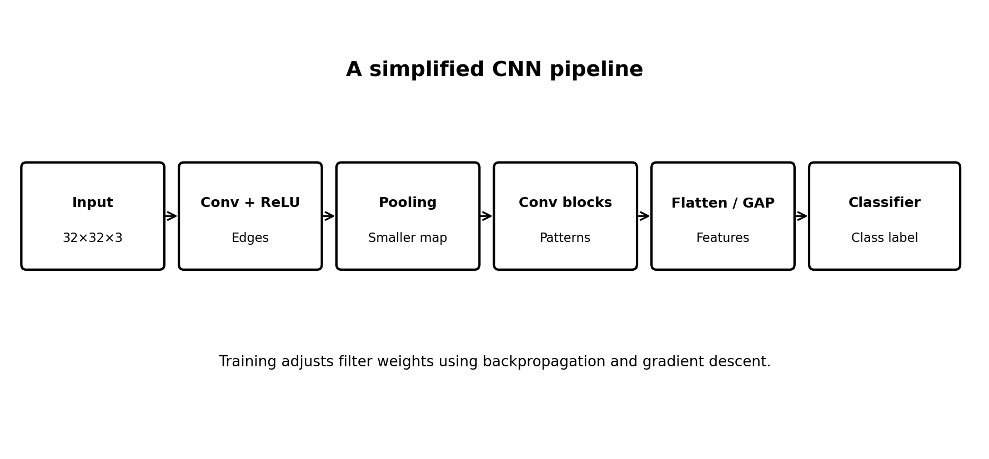
Architecture | Main idea | Strength | Typical limitation / note
LeNet-5 | Early compact CNN: convolution, subsampling/pooling, fully connected layers. | Small and easy to learn; influential for handwritten digit recognition. | Historically designed for small images; not as deep as modern networks.
VGG (e.g., VGG-16) | Stacks many small 3×3 convolutions with pooling between blocks. | Simple, regular design; useful for understanding depth and feature hierarchies. | Large parameter count and high memory/computation cost.
ResNet | Uses residual/skip connections: a block learns F(x), then adds x (when dimensions match). | Helps train very deep networks by improving gradient flow. | More complex block design; still needs careful training and compute.

Residual connection idea
Instead of learning a complete transformation from scratch, a residual block learns a change F(x) and combines it with the original input: y = F(x) + x (when shapes match). The shortcut gives information and gradients a more direct path through the network.
Memory aid: LeNet = compact classic; VGG = many stacked small convolutions; ResNet = skip connections for very deep networks.

7. End-to-end real-world example: detecting damaged products
- Capture: A camera takes a product image, for example a bottle with a possible crack.
- Preprocess: Resize to a fixed size, convert pixel values to tensors, and normalize consistently with training.
- Convolution: Learned filters respond to edges, highlights, texture changes, and crack-like patterns.
- Non-linearity: ReLU keeps positive activations and helps the network learn complex patterns.
- Pooling / strided convolution: Reduce spatial dimensions while retaining useful responses.
- Deeper blocks: Combine low-level signals into defect-related shapes and context.
- Classifier: Output probabilities or scores for classes such as 'normal' and 'defective'.
- Evaluation: Test on separate images from different lighting, camera angles, and product batches; review false negatives carefully.
Important: A high training score alone is not enough. Use a separate validation/test set, inspect class imbalance, and measure precision, recall, and confusion matrix. In safety-critical settings, keep human inspection and quality-control procedures.

8. Glossary
Pixel: smallest image element. Tensor: multi-dimensional array. Kernel/filter: small learned weight matrix. Activation: output of a layer. Feature map: spatial responses to a filter. Epoch: one pass through the training dataset. Overfitting: performing well on training data but poorly on unseen data. Inference: using a trained model to make predictions.

